Advance Soft Logics — AI/ML Internship
Week 2: Data Wrangling & EDA with NumPy and Pandas

Project Overview
This project delivers a complete exploratory data analysis (EDA) on a retail sales dataset, covering the full workflow expected of a junior data analyst: loading raw data, profiling it, building a documented cleaning pipeline, running groupby/merge/pivot analysis, producing labeled visualizations, and writing a plain-English findings summary grounded in the actual computed numbers.

What Was Built
- Phase 2 — Loading & Inspection: profiled shape, dtypes, missing values, and duplicates for both the sales and customers tables.
- Phase 3 — Cleaning Pipeline: standardized text casing, parsed mixed date formats, converted currency-string prices to numeric, imputed missing values by category median, and removed 12 duplicate rows.
- Phase 4 — Analysis & Visualizations: groupby aggregations (average sales by region, profit margin by category), a left-join merge with the customers table, a region-by-month pivot table, and 5 labeled charts.
- Phase 5 — Findings, README, and this report.

Dataset
The primary dataset (sales_data.csv, 332 rows x 10 columns) and a related customers.csv (150 rows) were constructed to closely mirror a real exported retail sales report, since the development environment used for this assignment has no general internet access to Kaggle/UCI. The data was deliberately seeded with realistic messiness — duplicate rows, missing prices/profits, mixed date formats, currency-symbol strings, and inconsistent text casing — so the cleaning pipeline addresses genuine, explainable problems rather than trivial ones. Both files satisfy the assignment's minimum size requirement of 200+ rows and 5+ columns.

Key Findings
- The South region had the highest average order value at $1,677.99, though the gap across all four regions was narrow — no single region dominates.
- Office Supplies had the best profit margin (14.86%) despite not leading in raw sales, showing that margin and sales volume don't move together in this dataset.
- Unit price correlates with total sale value (r = 0.74) far more strongly than order quantity does — large orders come from higher-priced items, not bulk purchases.
- An IQR-based outlier check flagged 29 of 320 orders on profit, concentrated in high-margin Electronics and Office Supplies sales.
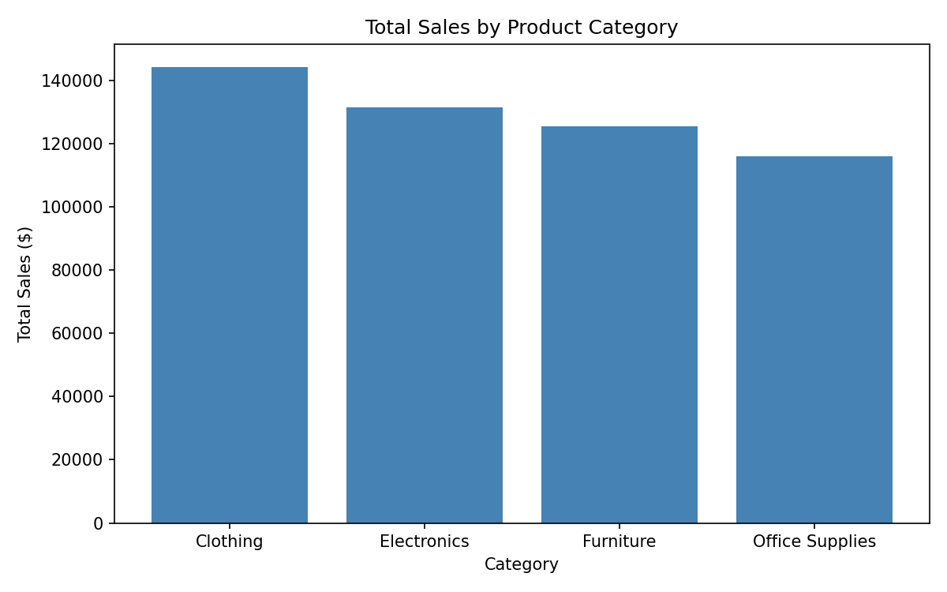
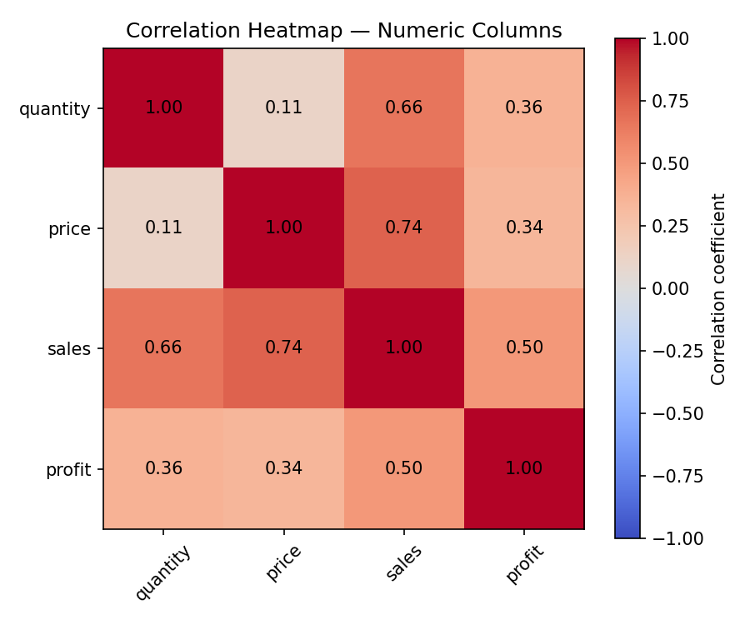

Challenges Faced & How They Were Solved
- Mixed date formats (YYYY-MM-DD and MM/DD/YYYY) in the same column — solved with pandas' format="mixed" parsing and errors="coerce" so unparseable values surface as missing rather than crashing the pipeline.
- Prices stored as currency strings for some rows only (e.g. "$235.55") — solved with a reusable clean_price_column() function that strips symbols before numeric conversion, rather than a one-off fix.
- Deciding how to fill missing price/profit values — a global median would have ignored real differences between categories, so values were imputed using the median within each row's own category instead.
- Choosing between an inner and left join for the merge step — an inner join would have silently dropped the 8 orders with missing customer_id, so a left join was used to preserve them while still surfacing the gap in the findings and README.

Bonus Features Implemented
- Outlier detection on the profit column using the IQR method.
- A correlation heatmap across all numeric columns.
- Cleaned dataset exported to data/processed/.
- Every repeated cleaning/analysis step wrapped in a reusable, independently testable function.

Rubric Self-Check (100 points)
Category | Points
Functionality (cleaning, groupby/merge/pivot) | 35
Code Quality | 20
Data Visualization | 15
Git Usage | 15
Documentation | 10
Bonus Features | 5

Conclusion
This project demonstrates a complete, reproducible EDA workflow with a clean Git commit history across five phases. Every cleaning decision is documented and justified in code comments, every chart is labeled, and the written findings reference real, reproducible numbers rather than generic statements. Full setup and run instructions are in README.md.

